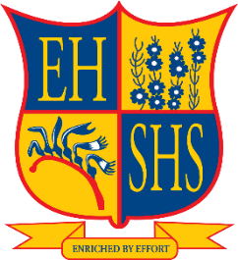
Partnerships for Success

July 2019 Newsletter
From the Principal
The whole school met at an assembly this morning to celebrate the achievements of Semester 1. This has been a very busy term with a number of significant events. NAPLAN had some issues which meant many students had to undertake both online and paper tests. The results are expected to be available in Term 3. I a,m sure that these will reflect the mature manner in which our students undertook what became an extended testing session. The sports programs have been growing in stature and achievement. The senior Girls Football team competed in the Grand Final of their division. Unfortunately they were narrowly defeated by Iona College in overtime. Our senior Student Council members recently visited Parliament House at the invitation of Hon Jessica Shaw MLA. The students were very impressed with the tour of the House. Following this they were later they were invited into the Dining Room for lunch. Many thanks to Ms Shaw for providing this opportunity.
Exams and assessments have been concluded for the semester and reports will be available to parents for all years by the end of semester. All reports are delivered electronically through Connect and email notice.
In Term 3 the school will be participating in the Speaking Out Survey which is organized by the Commissioner for Children and Young People. The Commissioner for Children and Young People would like to hear the views of children and young people about the things that matter to their health and wellbeing. He will be talking to students from Year 4 to Year 12 in schools across WA. The survey will be taken as a sample of students across year groups. If your child is offered the opportunity to participate, I encourage you to agree to them taking part in this important exercise.
A reminder that Day 1 (July 22nd) is a student free day with the staff undertaking Professional Development on a range of important initiatives. I trust all students will have a safe and refreshing break ready for Term 3.

Regards
John Dunning
Principal

Holiday Break

With the holidays fast approaching just a reminder of dates for everyone.
Last day of Term 2 is Friday 5th July.
First day back for students in Term 3 is Tuesday 23rd July 2019.
We hope you all have a safe and enjoyable break and we look forward to seeing you back in Term 3.

Girls Football

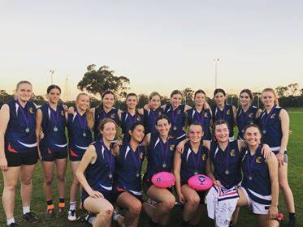

Eastern Hills Senior Girls have finished Runner Up in The Freo Dockers Cup White Division 2019. Congratulations to all involved in the competition. The girls have been an absolute pleasure to coach and have produced some quality footy.

A Special thank you to parents, families, teachers and friends who travelled to games in support of our amazing team.

Fantastic work!

Aspire Excursion
On Wednesday, 26 June, 30 Year 9 students participated in the Aspire UWA ‘Race around Campus’. This event was a great opportunity to show students various aspects of university life in a fun and interactive way. On the day, students rotated through a series of challenges located around the University.
They took part in taster activities from different faculties and student clubs and explored the campus.
Students had a great day and gained a better understanding of what life would be like as a university student.
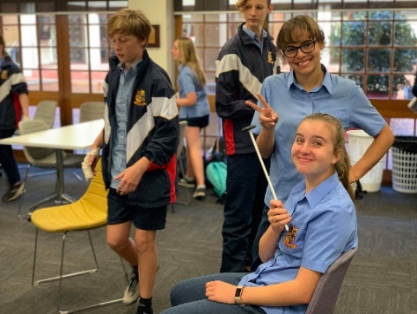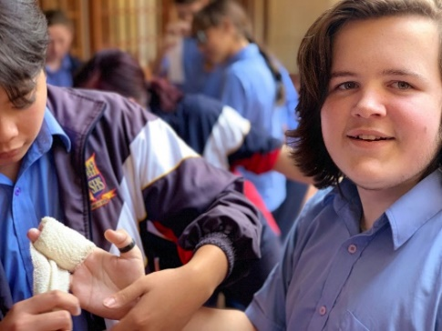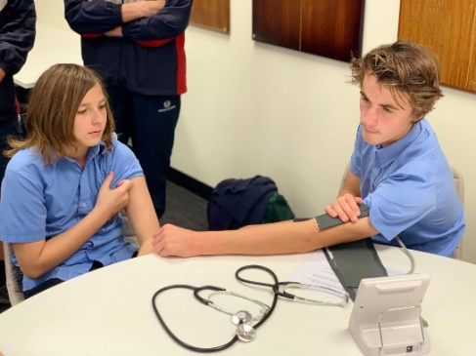

Year 7 Reward Excursion
This week our Year 7 students were rewarded with their end of term ice skating excursion at Mirrabooka Ice arena.
The students and teachers had a great day out. We would like to thank all our students for your outstanding behaviour throughout the day. Year 8 & 9 also enjoyed Reward Excursions, although not at ice skating.

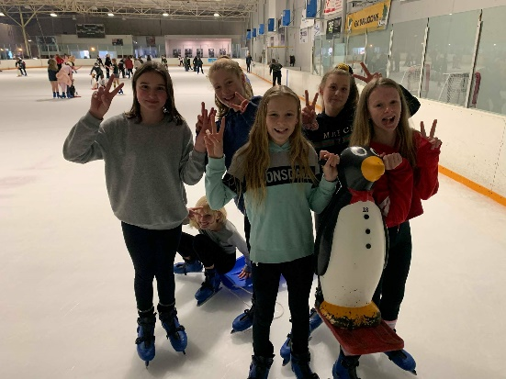

Parliament House Lunch
I am extremely proud of our senior councillors. They represented Eastern Hills very professionally and expressed great interest in everything they were shown. We started the day with a tour of both houses where Kimberly was Premier and Brooke the Opposition Leader for the tour (amazing how comfortable they both looked sitting in those seats). We followed up our tour with a wonderful 3 course lunch with Hon. Jessica Shaw MLA where the students discussed many different topics that affect both the young and old. An extremely successful day and congratulations to Evan, Brooke, Kimberly and Ryan.
Ms Hawthorne
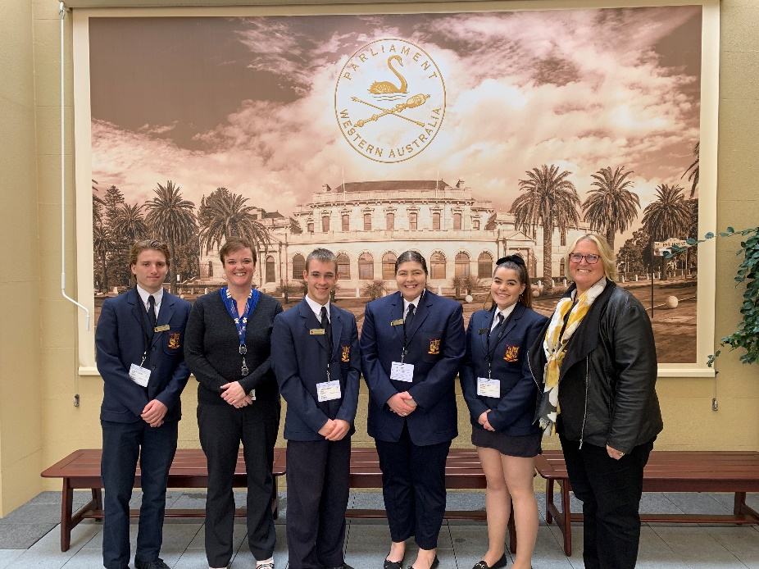
Dane Rossen
Well-deserved congratulations to Dane Rossen in Year 10 who is part of the Eastern Hills Senior High School Football Specialist Program. He was nominated by his school Specialist Football Program teacher/coach to attend tryouts for the AFL 15’s State School Boys Western Australian Team.
There was upward of 450 boys from all over the state of WA originally nominated to attend tryouts in April of this year.
On Friday night the 31st of May he received an email congratulating him on making it through the final tryout phase and being named as part of the AFL 15’s State School Boys Western Australian team, the team will be travelling to Launceston Tasmania on the 26th July 2019 for 10 days to play against teams from other states in Australia.
Dane said this is something he had only ever dreamed about but now realised that with hard work and dedication dreams can become a reality.
Well done Dane and good luck with the games in July.

Mid Year Concert
Last week Eastern Hills Music Department hosted its Mid-Year Concerts. Both evenings were a fantastic success with outstanding performances from all our bands, soloists, choir, students and staff.

We would like to thank all the families that came along on both evenings to support these very talented students and a huge thanks to all our staff as always for your ongoing commitment.

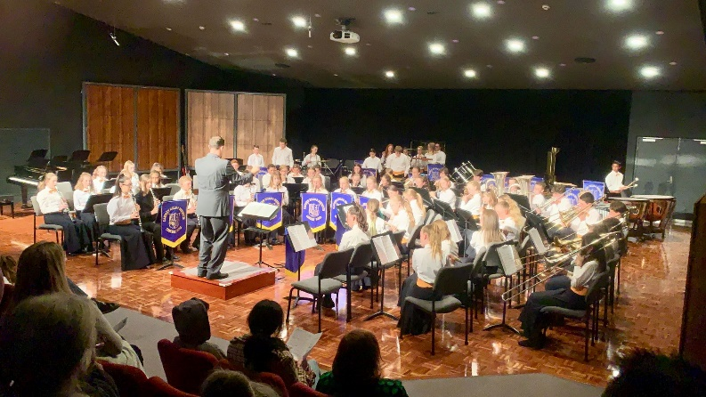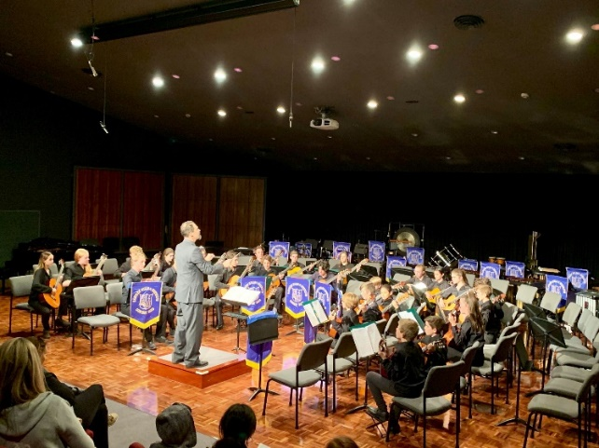
Eagles Visit
Yesterday the Year 7 and 8’s as part of the Eastern Hills football program took part in a West Coast Eagles football clinic. The morning consisted of a 45 minute practical skills component and a 45 minute in class workshop which was structured around nutrition, strength and conditioning, football life balance and other high level discussion topics. Lewis Jetta, Dom Sheed, Kurt Mutimer and Harry Edwards were the players that attended the clinic. The players gave some great advice and answered some great questions asked by the students. All involved represented Eastern Hills incredibly well and should be congratulated.
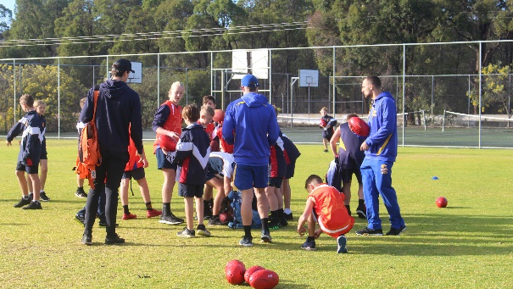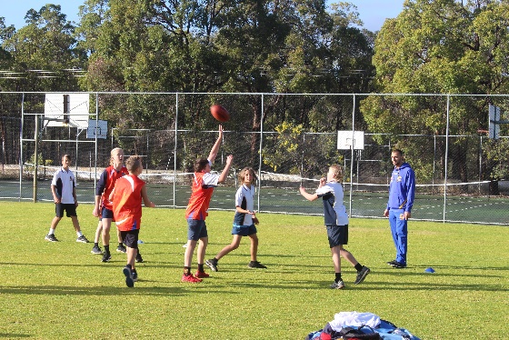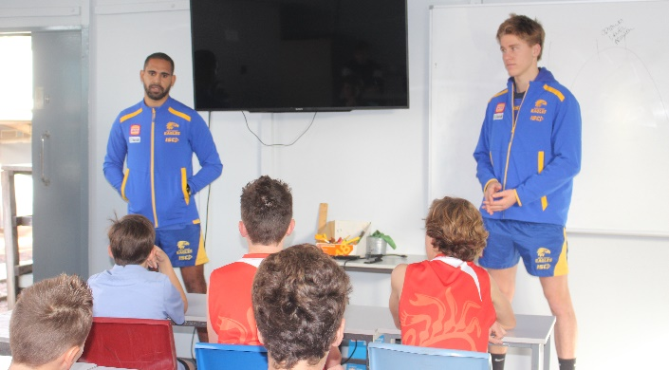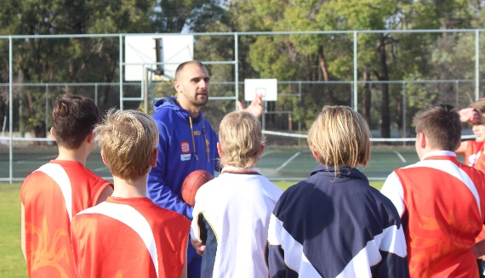
Applications for entry into the football program for 2020 are now open. See the school website or contact Jake Davis at jake.davis2@education.wa.edu.au for more information.

