Eastern Hills Senior High School
Keane Street East
MT HELENA WA 6082
Phone: 9573 0200
Email: EasternHills.SHS@education.wa.edu.au

July 2020
ONLINE COURSE SELECTION INSTRUCTIONS FOR 2021

Dear Parents and Carers,

We’re pleased to advise you’ll be able to choose your courses for next year using SSO’s online system. You’ll be able to access SSO from Tuesday 21 July 2020 until Friday 31 July 2020 at 11pm.

You can access your selections by going to the following website:
https://client.subjectselectiononline.com.au/?school=2ggg8

How do I log in?
- You will need to go the website above and click on the Forgotten your Password? link.
- Enter your students Department of Education email address (for example, john.smith@student.education.wa.edu.au ), and click Submit:

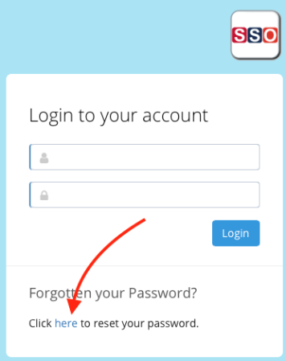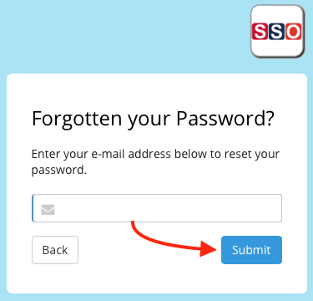

- An email will be sent to the email address that was entered, if it has been entered correctly. This email will contain a blue tab saying Login and Reset Password. Click on the tab.
- Set a new password.
- You will then be redirected to the website to login to complete your online selections.
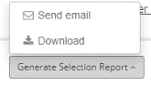
- When you’ve completed the selection process, you will be able to print or email a copy of the selections to yourself using the Generate Selection Report – Download/ Send email function.

What needs to be done once logged in?
Read the information and complete the instructions that appear on the screen. You can see which instructions you’ve completed correctly, when they are marked with a green tick in the left margin.

What do I need to do as a parent/carer?
Discuss the selections with your child. It’s also a good idea to sit together and read the information.

Where do I get more information?
Further information on each subject is available in the Course Information Handbook on the school website, along with all other supporting documents and videos. https://www.ehshs.wa.edu.au/course-selection-information

What do I do if I need help?
If you need help with logging in or making selections, please contact the applicable Course Counsellor
Year 7 – Ms Edwards charlotte.edwards@education.wa.edu.au
Year 8 – Mr Vagg sean.vagg@education.wa.edu.au
Year 9 – Mr Smith benjamin.smith2@education.wa.edu.au
Or call the Front Office for assistance on 9573 0300.

Kind regards
Raelene Infanti - Acting Deputy Principal (raelene.infanti@education.wa.edu.au)

