CANBERRA – SOVEREIGN HILL – MELBOURNE TOUR 2019
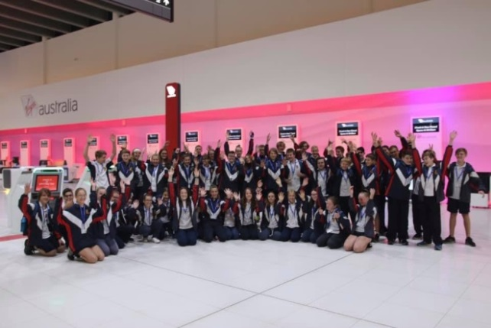
On April 7th a mix of 50 excited Year 9 and 10 students met at Perth Airport ready to embark on a one week cultural tour of Canberra, Sovereign Hill and Melbourne. While students had been preparing and looking forward to this for months, they were soon to realize how tight the daily schedules were going to be.
Day One began with an early morning flight from Perth (they had to be at the airport at 4:30am!) through to Melbourne for a quick stopover and then on to Canberra arriving at 4:30pm. The first stop in Canberra – an afternoon tea break at Mc Donald’s giving students time to chill out, chat and prepare themselves for the week ahead.
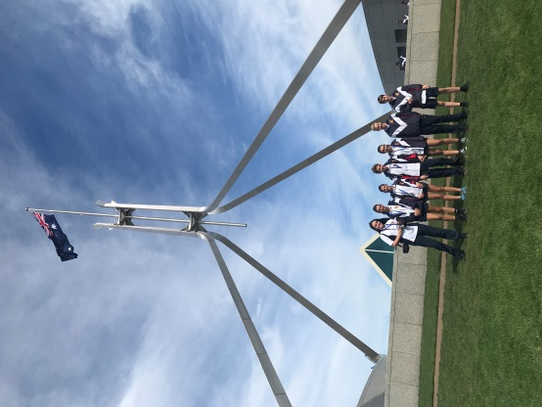
Day Two saw the beginning of the Political part of the Tour. Parliament House was a highlight of the tour giving an opportunity for students to look at both the Senate and The House of Representatives. A mock government was formed where students were divided into two groups representing the Government and the Opposition. This enabled them to voice their opinions in a debate as would occur in parliament when a bill is to be passed.
After spending time on the top of Parliament House taking photo, a lunch break in the grounds of Old Parliament House was most welcomed. Students then attended the Museum of Australian Democracy and took part in an “Our Voices, Our Choices” Education Programme.
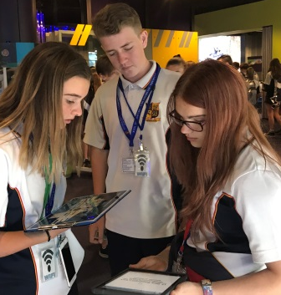
Eastern Hills Senior High School students are very competitive, and this was brought to light once we reached the CSIRO Discovery Centre. A challenge was given and our students willingly accepted, racing around the displays looking for answers to scientific questions.
For the best view of Canberra, students were taken to Mount Ainslie Lookout. The day ended at the Australian Institute of Sport. Students marveled at the abilities of the training athletes and the state of the art equipment that was available to them. Students were then able to show off some of their own sporting prowess at Sportex where they had the opportunity totry their hands at a number of different sports as well as competing against each other.
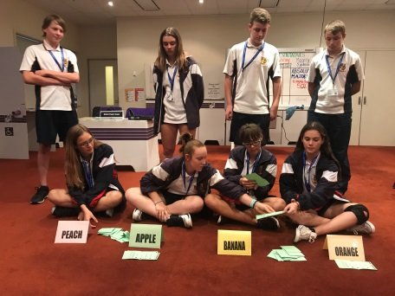
Day Three began with a visit to the National Capital Exhibition where students learnt about the history of Canberra. The Australian War Memorial was a site that many had looked forward to seeing. Students were given the opportunity of saying “The Ode” and laying poppies on the Grave of the Unknown Soldier and paying their respects to those who had lost their lives defending our country. Students were then driven to the National Museum of Australia where they learnt about our history. For the first time this tour, students were divided into their year groups with the Year 9 students heading off to the National Electoral Education Centre where they would learn about Australia’s electoral system. Here they conducted a mock election in order to understand the workings of the preferential system of voting. Meanwhile the Year 10’s were taken to the Aboriginal Tent Embassy and the Embassy and Lodge District before heading off to the shops to stock up for the long bus ride to Sovereign Hill.
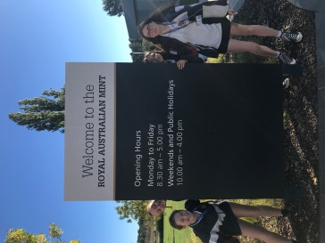
Our Fourth day touring involved a stop at the Royal Australian Mint where students watched the process of coins being made before making one of their own,.Next on the itinerary was a visit to the High Court of Australia where it was explained to students that the building was designed with a lot of windows to reflect the transparancy of the court and Australia’s legal system.

After a morning full of facts, figures and how to’s, students were treated to a cruise on Lake Burley Griffin. Whilst it gave students a chance to put their feet upand relax, it was also full of interesting commentary about the surrounding buildings and the history of the lake itself.
A visit to Questacon ensured students were on their feet again giving them the chance to explore Science in a fun and challenging manner. Once again students were divided into year groups as this time the Year 10’s completed a session at the National Electoral Education Centre and the Year 9’s spent time learning about the Aboriginal Tent Embassy before completing a driving tour of the Embassy and Lodge District. After hearing about the Year 10’s shopping expedition yesterday, the the Year 9’s were prepared! They had planned ahead and were very quick in selecting their “delicacies” for the following days journey.
Day Five was spent on the bus. A long day of travel from Canberra to Sovereign Hill allowed students time to catch up on some much needed sleep. Stops at “The Dog on the Tuckerbox”, Holbrook and Glenrowan - home of Ned Kelly - broke up the long journey.

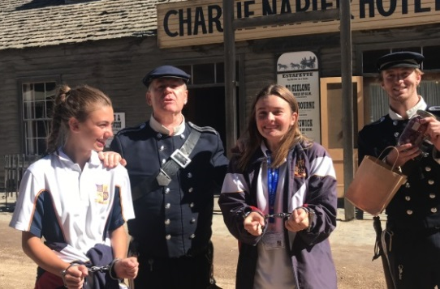
Sovereign Hill was a place where students were able to step back in time. An evening performance of Blood on the Southern Cross had students prepared for the following days activities. A morning visit to the Gold Museum was followed by students checking out the stores in Main Street, going down a gold mine and then trying their luck panning for gold. After a morning packed full of activities, students boarded the bus for the final leg of the journey – destination Melbourne! As no visit to Melbourne is complete without a visit to “the home of football” the MCG students were treated to the Friday night blockbuster match – Collingwood vs The Western Bulldogs. The Collingwood victory made the visit to the MCG just that much more special for our Collingwood supporters.

Melbourne offered students a different type of education. A walk through Federation Square and Graffiti Alley was followed by a tram ride to the Queen Victoria Markets where students began their spending. A visit to South Wharf DFO ensured that all shopping tastes were covered. As Melbourne is the home of football, what better way to spend a Saturday night than at Marvel Stadium to watch North Melbourne take on the Adelaide Crows.

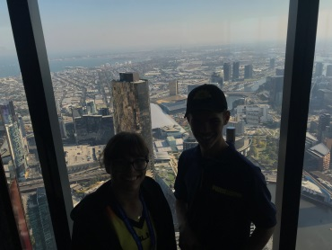
Our final day involved a guided tour of the MCG providing an insight into this historic stadium. The National Sports Museum allowed students the opportunity to see the equipment used and the clothing worn by our sporting elite before once again challenging themselves on the interactive sporting equipment that was available. The view from the Eureka Skydeck 88 was amazing, giving students a chance to relax before hitting the courts at The National Tennis Centre.

An early evening flight home saw the end of what had been an amazing tour. Over a week, students had been part of so many new opportunities and experiences. Educational programmes focusing on Australia’s history, culture, heritage and democracy were all well received by the students.

Both staff and students felt this Tour was very rewarding. Ms Rawle, Mr Davis, Mrs De Swardt, Ms Tunstead, and Justin (Chaplain) would like to thank the students for being part of this experience. Their excellent behaviour, co-operation and attitude throughout the week earnt them accolades wherever they went. It was a credit to them and it was our privilege to have been a part of this extraordinary group.

The Australian Government recognizes the importance of young Australian’s being able to visit the National Capital as part of their Civics and Citizenship education and the provision of a Parliament and Civics Education Rebate (PACER) of $240 per eligible student toward travel expenses has assisted parents in meeting the cost of this tour.

The Humanities and Social Sciences staff at Eastern Hills Senior High School looks forward to offering a similar experience in 2021.

BALL 2019.

Last term our upper school students and staff attended the School Ball at Government House. The evening was a wonderful success highlighted by Ballroom dancing by our students and special guests from Empire Dance Studio, everyone dazzled in beautiful gowns and suits with some very happy students gaining special recognition for Belle and Beau for Years 11 and 12 and most transformed in both year groups as well.
Thank you to everyone for another wonderful event.

